**ETL Group Project: Drew, Charles, Hayden**

October 2019

**Executive Summary:**

This is the most amazing project ever! We finally are able to put all of the piece together and do some real analysis. Our group decided to analyze the opioid crisis and determine if there are any trends by state, opioid type or Dr types prescribing them. Our findings include:

* Sdflksdjfd
* dfsdfsdf

**Sources of Data:**

1. U.S. Opiate Prescriptions/Overdoses: <https://www.kaggle.com/apryor6/us-opiate-prescriptions#overdoses.csv>
2. Drugs prescriptions with providers profile: <https://www.kaggle.com/tajuddinkh/drugs-prescriptions-with-providers>
3. 12 Month-ending Provisional Number of Drug Overdose Deaths from CDC: <https://www.cdc.gov/nchs/nvss/vsrr/drug-overdose-data.htm>

**Data Dictionary:**



**Two graphs that lead to cleaning:**

sdfsdf

**ERD:**

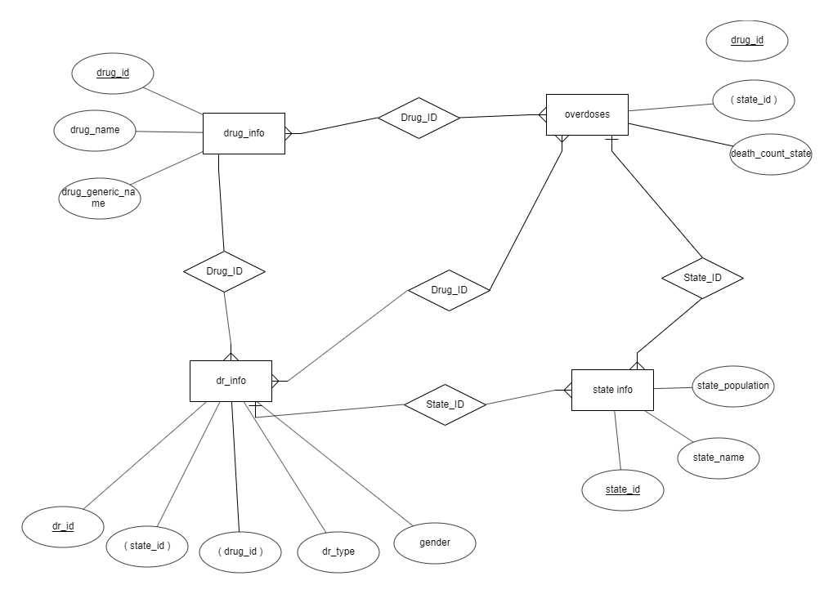

**Table Schema:**

-- ETL table schema

--Opioid Table

CREATE TABLE opioids (

drug_id INT PRIMARY KEY

drug_name VARCHAR(30)

generic_name VARCHAR (30)

);

-- Overdoses Table

CREATE TABLE overdoses (

state_id INT

deaths INT

FOREIGN KEY (state_id) REFERENCES states(state_id)

);

-- State Table

CREATE TABLE states (

state_id INT PRIMARY KEY

state_abbv VARCHAR(30)

state_name VARCHAR(30)

state_pop INT

)

-- Doctor Table

CREATE TABLE prescribers (

doctor_id INT PRIMARY KEY

doctor_type VARCHAR (30)

drug_id INT

state_id INT

gender VARCHAR (1)

FOREIGN KEY (state_id) REFERENCES states(state_id)

FOEIGN KEY (drug_id) REFERENCES opiods(drug_id)

)

**Five Queries:**

sdfsdf

**One Notebook and One SQL:**

sdfsdf